**Project Proposal - Group-4**

**Eco-Management Assistant**

1. **Aim:**

Our main purpose is to assist people with how to use the commonly used objects and waste materials effectively and suggest alternatives if any such that we can promote sustainable development goals (goal numbers:3,11,12,13 and indirectly also affect goal numbers:6,14,15) which also helps in mass awareness in the public.

* 1. **Learning Intended:**
     1. On how different types of waste, household products, and soils can be utilized efficiently.
     2. Learning about waste management in India relative to other countries.
     3. Categorization of waste that is most commonly generated.
     4. Application of 3R’s - Reduce, Reuse and Recycle to the commonly found objects and materials.
  2. **Achievable Post Conditions:**
     1. Assists people to easily navigate through different ways to efficiently use or dispose of commonly found materials and appliances.
     2. Information on the adverse effects caused by the materials helps create awareness.
     3. Using an Image Recognition cum Search based app helps the user to easily find the intended efficient result tailored particularly to promote sustainable usage.

1. **Roles:**
   1. Gaurav Kumar ( CE20B009 ) - App Development and Implementation
   2. Ambati Pooja Sree (CS20B002) - Data collection
   3. Guddeti Namitha Reddy (CS20B011) - Data collection and creating Presentation
   4. Kamepalli Nithin (CS20B014) - Data collection
   5. Preethi Varsha Marivina (CS20B030) - Writing Reports, App Layout and Presentation *(Team Representative)*
   6. Ritesh Ranjan (CS20B033) - Data collection
   7. U. Kushwanth (CS20B050) - Data collection
   8. Yash Wardhan Singh Chandravath (CS20B052) - Data collection
2. **Methodology:**
   1. **Methodology following:**
      1. Searching through various websites, blogs, news articles on the internet to collect, organize and analyze data.
      2. Data is collected in a mixed way containing both secondary sources and primary data.
      3. We are using both qualitative and quantitative data.
      4. Data collection is descriptive in most parts of the project. No intervening information is done.
      5. Sampling methods:
         1. Efficient practices for waste management and usage of household materials and soils are categorized based on Biodegradable and non-biodegradable, which is further subdivided based on 3 R's - Reduce, Reuse and Recycle.
         2. Data is presented in a concise manner with images.
      6. Data analysis is done through pie charts and other graphical forms mostly using excel features.
      7. Tools used:
         1. Android Studio - to develop android applications. (Image recognition and search based app)
         2. Tensor flow open source libraries.
         3. Internet - various sources like websites, news, articles, government databases, and blogs to collect information.
      8. Why chose this project? - We wanted to develop something that actually has a practical application and provides mass awareness among the public.
   2. **Collection of Data:**
      1. As a data-intensive project, we collect data from various sources on the internet (different websites and blogs).
      2. Images and depictions used are mostly open sources and if any sentences are used from a website citations are mentioned.
      3. Surfing through a lot of content, we filter and present only the usage, reduce, reuse and recycle methods that are efficient and have practical implications.
3. **Expected Outcomes:**
   1. Assists people to easily find different ways to effectively use or dispose of commonly found materials and appliances.
   2. Providing information on the ill effects caused by the commonly used materials will help create mass awareness.
   3. Easy and Handy information shall help people make a step towards a sustainable society.
   4. Analysis on how Waste can be managed better in India.
4. **Work Plan:**

**Gantt chart for our project.**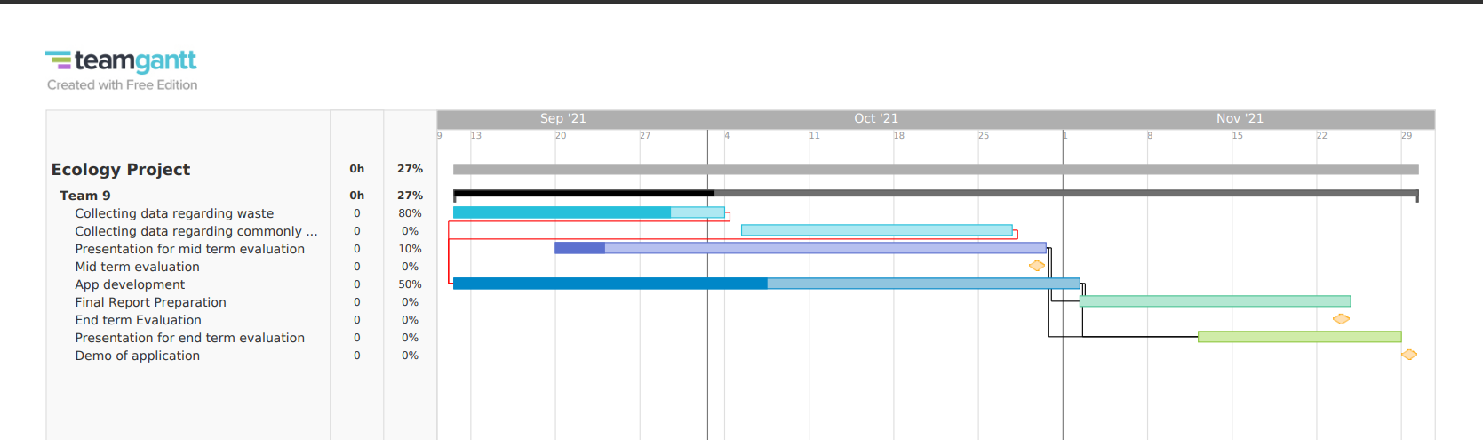

* **Step 1:** App layout and design, app basic structure, collect data regarding different types of waste materials.
* **Step 2:** Integrating all collected data into the app.
* **Step 3:** collecting data regarding various household or commonly used appliances.
* **Step 4:** Integrating the data collected into the app and add any modifications.
* **Step 5:** Preparation of reports and graphical models.

---**Thank You**---